Olympic Games — Analysis and visualisation of history with R and prediction of model for medals
Poulami Bera, Tanushree Gorai, Vansh Shan
3rd year Computer Science Department, Vellore Institute Of Technology

Abstract— The Olympics is an international sporting event with over 200 countries participating in various competitions. Athletes from different countries compete and make their countries proud of their sporting excellence. Despite their huge populations, many of the most populous nations do not win many Olympic medals. The main purpose of this white paper is to use Python to analyze the Olympics dataset, compare the overall performance of each country, and evaluate each country's contribution to the Olympics. These analyzes provide greater insight into each nation's performance at the Olympic Games over the years and help athletes quickly analyze their own and their competitors' performance. This paper uses exploratory data analysis techniques to compare the performance of different countries and their contribution to the Olympic Games. Various dimensions of the Olympics dataset are visualized to provide a country's status in the Olympics, help underperforming countries produce quality athletes, and improve their performance in the Olympics. increase.

Keywords— International, Excellence, Performance Analysis, Data Visualization
- Introduction
The Olympic Games are considered the most important event in the world, providing a common platform for athletes from different countries to showcase their talents. The Olympic Games began in his 1896 and are held every four years. The purpose of this work is to analyze each country's performance and participation in the Olympic Games from 1896 to 2012. Also, specific national sports disciplines can be identified in specific years in which they made the greatest contribution. You can compare the performance of each sport with other sports. Sports areas in need of greater participation can be identified and athletes and countries can take the necessary actions to improve their future contribution to the Olympic Games. Olympia record.
Section 2 describes related work based on a literature review. Section 3 discusses performance analysis and visualization, and Section 4 concludes the paper on the importance of analysis.

- Domain

Medals, Population and GDP data:
Data from the 2008, 2012, and 2016 Olympic Games were collected for this analysis. Only those nations with multiple medal winners are taken into account. Features include nation name, GDP, population, and Olympic medals from 2008, 2012, and 2016. Data includes 71 countries.

- Country
- GDP
- Population
- Medal2008
- Medal2012
- Medal2016
The goal of this work is to attract Olympic fans and provide them with honest answers to their questions. The primary data set used in this analysis was obtained from Kaggle and is split into two tables: athlete events and event regions.
Two distinct data frames will be used in the visualisation process. The dataset was reviewed, and it was agreed that the dplyr package would be used to make the data more relevant and realistic without removing any data.
The athlete's age, weight, and height are not included in these instances but can be used in your own in-depth examination of the data.

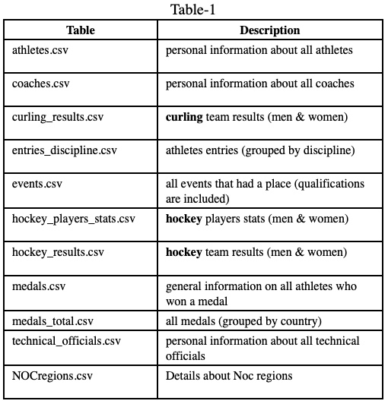
Datasets description :

- LITERATURE SURVEY
Analysis of 120 years of the Olympic Games By Karolina Grodzinska –
Exploratory data analysis (EDA), which is not a formal technique, entails looking into a variety of concepts that come to the analyst's mind when dealing with a dataset for the first time. It aids in improving understanding of the dataset. While some of the original concepts will out to be fruitless, others may provide useful insights. Exploratory data analysis is a crucial component of data analysis. It involves formulating questions about the data, looking for answers by visualising, transforming, and modelling the data, and then using what was discovered in the earlier stages to either clarify the questions or formulate new ones. The primary objective of this EDA survey is to generate numerous promising avenues for further investigation during the subsequent data analysis phase (R for Data Science).

Olympic Data Analysis by Kabita Paul, Elif Demir, Anjali Bapat –
Application makes use of practical analytical examples and makes the argument that it offers consumers an effective, practical, efficient, and convenient model. The discussion, conclusion, and future work are enumerated together with a request for suggestions on how to address the shortcomings, which were examined in another section of the review. The dashboard's main objective is to describe how the user could profit from the produced system having visual representations. User interfaces are quite significant, straightforward, and easy to use when educating people about the Olympics. If the product doesn't match the specific standards, the evaluation should at least take efficiency and effectiveness into account.

Data visualisation
While R's many graphing systems have their uses, one of the most sophisticated and flexible is ggplot2. The language of graphics is a unified framework for describing and constructing graphs, and ggplot2 supports this. You can get more done in less time with ggplot2 because it only requires understanding one system.

OLYMPIC GAMES MEDAL COUNT ANALYSIS SUMMER AS WELL AS WINTER OLYMPIC GAMES - A Thesis Presented to the Faculty of California State Polytechnic University, Pomona –
Four major analysis sections make up this report. The first section provides background information on the Olympics. We examine the fundamental study of the Summer as well as Winter Olympics in the second section. The joint study of the Summer and Winter Olympic Games is presented in the third section. We'll look at the fourth section, which compares the amount of medals won at the Summer along with Winter Olympics. At the same time, in 2012 and 2014, the average high temperature in winter and GDP per capita were incorporated in order to show the connection between the number of medals and the fundamental characteristics of each country. The number of medals a nation wins is influenced by the correlation between the average high temperature in winter and GDP per capita.

120 Years of Olympic Results Analysis - Kassidy Chaikin, William Wenzel, Emily Lepore, and Christopher Egan

Investigating how gender imbalance in Olympic participation has changed over time can help us determine which nations have a higher proportion of women. To examine how biological characteristics affect medal winners for male and female athletes, we will particularly examine four sports, two from the Winter and two from the Summer Olympic Games. We also want to take a closer look at two particular athletes who have participated in numerous Olympic Games to determine how ageing may affect their performance and whether they are more or less likely to take home a medal.

DATA ANALYSIS ALONG WITH THE VISUALIZATION OF OLYMPICS USING PYSPARK AND DASH-PLOTLY - Harshal S. Kudale, Pooja J. Chittar, Kalpesh P. Zarkar, Mihir V. Phadnis, Prof. Balaji K. Bodhke

Data analysis on the ancient Olympics data set is briefly discussed in this paper, and the results are visualised for a more engaging final product. Since Apache Spark is about a hundred times faster than Apache Hadoop in in-memory facts processing and offers API support for a wide variety of languages, including Java, Python, Scala, Ruby, R, etc., while Hadoop typically used Java as its default language, we've decided to use it for our data analytics work due to its compatibility and ease of use. We've decided to use PySpark, Apache Spark's Python API, because it provides access to a wide variety of useful analytical tools, such as SparkSQL for query management, Spark MLLib for machine learning, Spark GraphX for graph processing, etc. Dash-Plotly is a package we're using to make high-quality, interactive web apps with a focus on data visualisation.This paper's subsequent sections take us through the literature review in phase II, the proposed architecture in phase III, an overview of the technologies employed in the course of the assignment in section IV, their application to the project in section V, the project's workflow in section VI, and the results of its implementation in section VII.

Analysis of gymnast over the time –
Modern statistics can address the problem of judging gymnastics in different ways. The ongoing statistical analysis of individual judges' scores helps the sport in three ways. First, he can identify judges who score consistently high or low compared to their peers. This is an issue that judge selection or judge training can address. You can then identify the judge with her rating pattern that is unusual. This helps expose and eliminate potentially corrupt or biased judges. Third, it helps show the public that most gymnastics judges are presenting scores correctly. Public trust in the evaluation process is paramount. We will analyze a sample of Gymnastics scores to create a system to assess if 1) judges have a general bias, 2) judges have a targeted bias toward ‘power countries’, and 3) if there is an inflationary bias that occurs as the event progresses.

EDA to Examine the Evolution of the Olympics using R - Pradhan, Rahul; Agrawal, Kartik; Nag, Anubhav
This research paper's main goal is to evaluate how the Olympic Games have changed over time by performing exploratory data analysis on a sizable Olympic dataset. This analysis will present information in a graphic style that is precise and in-depth about many elements that contribute to the improvement of countries and athletes through time and to the evolution of the games in Olympic. The data visualisation over many parameters will provide us a statistical picture of the many factors that contribute to the development of the Olympic Games and the improvement in the performance of different countries/players over time.

Comprehensive Guide to Data Visualization in R-

For developing visualisations and presenting data, R programming provides a compelling set of built-in functions and packages (ggplot2, Leaflet, Lattice, and so on).
In this article, we've covered the steps to create general and advanced visualizations in R programming. Before that, let's take a quick look at the history of data visualization.

Data Visualization in R-

The 'Grid' graphics system developed by Paul Murrell (2011) is implemented in R by the 'Grid' package. "Grid" graphics provide a low-level alternative to the standard graphics system. An important point to note here is that while "grid" graphs offer software developers a lot of flexibility, they do not provide statistical graphs or full plots. The lattice package, developed by Deepayan Sarkar (2008), implements the trellis graph outlined by Cleveland (1985, 1993). That is, a trellis plot shows the distribution of a variable, or the relationship between variables, separately for each level of one or more other variables. The Lattice package is built using the Grid package to provide a robust framework for visualizing multivariate data and a comprehensive alternative system for creating statistical graphs in R. There are many other packages such as functions (Effects, Flexclust, Hmisc, Mice, and OdfWeave). Generate the graph using the 'grid' package

Data Mining and Visualization of Olympic Games Results Based on R Language.
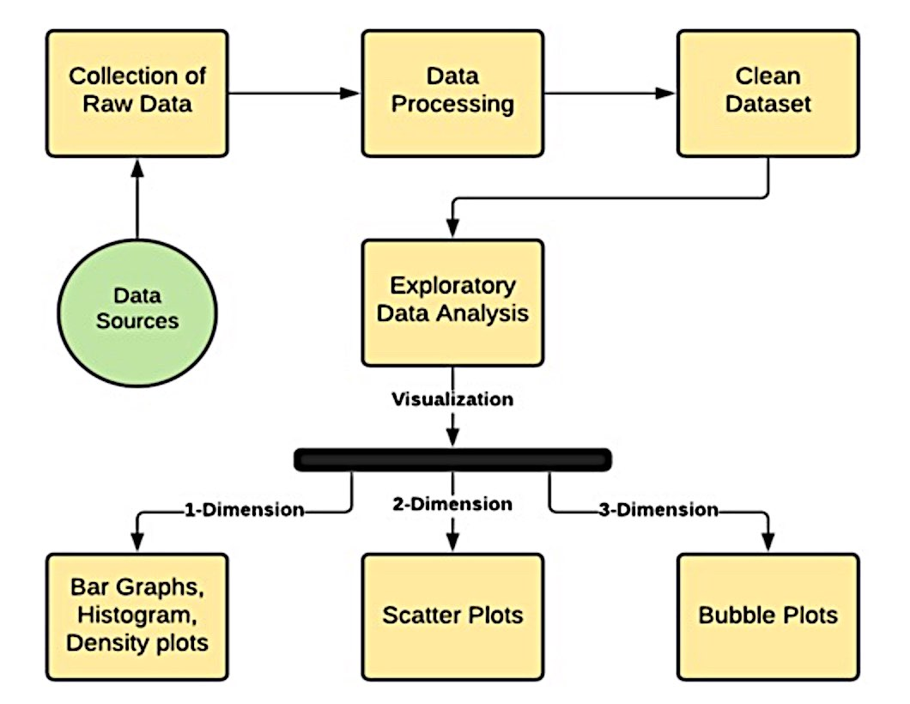
This paper uses data mining and visualization techniques to analyze Olympic Games results. The authors use R programming language to examine patterns and trends in the data, such as changes in medal counts over time and the impact of different factors on medal success. They also use various visualization tools to represent the data in a user-friendly and interactive way.

Visualization of Olympic Games Results Using R

This paper focuses on the visualization of Olympic Games results using R programming language. The authors use various data visualization techniques, such as heatmaps and scatterplots, to represent different aspects of the Games, such as medal counts, performance by country, and trends over time.

A Time Series Analysis of Olympic Medals
This paper applies time series analysis techniques to data on Olympic medals won by different countries over time. The authors use R programming language to examine trends and patterns in the data, including changes in medal distribution and the impact of factors such as host country advantage and technological innovations.

A Prediction Model for Olympic Medals
This paper presents a prediction model for Olympic medals based on data from previous Games. The authors use machine learning algorithms to identify the key factors that contribute to medal success, such as economic and demographic indicators. They also incorporate data on athletes' performance and training to refine their model and improve its accuracy.

Historical Analysis of the Olympic Games Using R
This paper examines the history of the Olympic Games using R programming language. The authors analyze data on medal counts, participating countries, and other variables to gain insights into the evolution of the Games over time. They use various statistical techniques, such as clustering and regression analysis, to identify trends and patterns in the data.

- Methodology used:
Figure-1

Data collection :
Gathering relevant information is the initial step in any analysis, technical or otherwise. In order to analyse a problem, we require a large amount of data, which we then process using a number of different methods and algorithms. Collecting a large amount of data is recommended because doing so increases the reliability of your analyses and the certainty with which you can act on your findings. We have used data from a wide range of sources to examine the evolution of the Olympic Games.
Data pre - preprocessing:
Data processing comes next after data collection. Raw data is information that has been taken straight from a dataset or other data source. The dataset includes a number of fields, including Age, Gender, and others, some of which include null values, which leads to problems in the final product, which is the graphical visualisation of the data. These null values must be removed or replaced with other valid values in order to correct the issue and produce accurate results. To finish this assignment, we employed a process called Deterministic Imputation. During a process known as "deterministic imputation," the information from the other values in the same column is used to calculate the NA or NaN values. Several models exist for this purpose; one of them is the Basic Numeric Imputation Model, in which the missing value is replaced by the median or mean of the other values in the same column of the dataset.

Exploratory Data Analysis:
After collecting and cleaning data, the next step is to analyse it. Data is analysed at this stage using a wide range of methods, including text analysis, diagnostic analysis, exploratory data analysis, and so on, as well as machine learning algorithms like linear regression, logistic regression, support vector machines, decision trees, and so on.
Using the numerous graphs and plots that may be generated by EDA, we can gain insight into the structure and substance of the dataset. In EDA, we employ a wide variety of plot types. The following are examples of some of them:

Chart Types: Histogram, Bar Graph, Box Plot, and Scatter Plot

- ALGORITHM USED
We built four models, each employing a different algorithm for predicting Olympic medals, and chose the one whose predictions were most consistent with the actual medals earned by each country.
These are the algorithms we use:
- Linear Regression Model
- Linear transform to log transformed value
- Poisson Regression
- Binomial Regression - Negative

Linear regression model

A statistical model termed "linear regression" explores the connection and interactions between a response variable (usually abbreviated "y") and one or more additional factors (often called x or explanatory variables). You create associations of this kind in your thinking all the time. Inferring a child's age from her height, for instance, assumes that the older she is, the taller she will be. The usage of linear regression, which dates back to the 19th century, and whose results can be readily understood by most people, makes it one of the most basic statistical models now accessible. The popularity of linear regression can be attributed to this. It is simple and has been practised for ages.

Medals won=β0+β1(GDP)+β2(Population)+ϵ ,ϵ∼N((0,σ2))

Linear transform to log transformed value

Logarithmic transformation is a useful tool for transforming data with a high degree of skewness into a more normal distribution. When modelling variables having non-linear connections, there may be an increased risk of making mistakes. In theory, we want to get a forecast with as little error as possible, but we also need to be careful not to overfit the model. When there are an excessive number of dependent variables, the dataset becomes overfitted, rendering forecasting impossible. Taking the logarithm of one or more variables improves the model's fit by shifting the distribution of the features to a bell curve.

Poisson Regression
A sort of regression analysis model called Poisson Regression in R is used for predictive analysis when there are several predicted outcomes that can be counted in numbers. The Poisson regression model may be calculated and evaluated using built-in functions in the R programming language. By employing one or more explanatory variables X, Poisson regression is beneficial for predicting the value of the response variable Y. This discrete probability distribution is the one that is preferred. Predicting the amount of leads in an organisation that will turn into customers within a specific time frame is one use for a Poisson regression model.

Negative Binomial Regression
The mean and standard deviation of the Poisson distribution are the same number, . Remembering it is simple, but its usefulness is limited. In most cases, the variance of a count distribution will exceed the mean. If the variance is smaller than the mean, we have under-dispersion, and if it is larger than the mean, we have over-dispersion, with data that we assume (or hope) is Poisson distributed. Poisson regression doesn't work well with this kind of trending count data.
One approach to fixing this issue is using negative binomial regression. Both the Poisson and the negative binomial distributions can be thought of as the probabilities associated with whole numbers greater than or equal to 0. Unlike the Poisson distribution, in which the variance equals the mean, this one does not. This demonstrates its potential as a rough estimate for modelling counts with variability that deviates from the mean. The dispersion parameter k contributes to the variance of a negative binomial distribution, which itself is a function of the mean. Using the negative binomial distribution as an example, the variance of the number we're counting would be

Varr (Y) =μ+μ2/k

The variance converges to the mean's value as the dispersion parameter increases, converting the negative binomial distribution into a Poisson distribution.

- ANALYSIS AND RESULTS
A dataset of the Summer Olympics was examined [6], which included data sets from 1896 through 2012. There are 9 columns and about 30,000 rows in this data collection. Year, Sport, Discipline, Medal, Gender, Country, City, Event, and Athlete are just a few of the fields. [6]
- Comparing the number of athletes, countries, and events has been increasing over time.
We can observe the growth in the number of athletes, nations, and events. From 1950 to 1980, participation in summer activities decreased, but then increased again until the Rio Olympics.

Winter Olympic participation rises through time steadily, whereas summer Olympic participation fell during the 1980 Games before rising again.
Figure -2
- Finding the sum of a country's Olympic gold, silver, and bronze medals from 1896-2016.

This research shows how many gold, silver, and bronze medals were won by competitors from every nation at the Olympic Games between 1896 and 2016. The total includes all those who gave money—individually or collectively—to help their nation win a medal.. The outcomes of the analysis were as follows: I When compared to her for the other medals, the USA has the most gold medals, with a virtually equal share of silver and her bronze medals. (ii) Japan has more gold medals than any other country, although Australia has earned the fewest gold medals overall and the most bronze medals. Compared to her 4,444 silver and bronze medals, France has less gold medals.

Figure-3
- To identify the count male and female athletes over time (1896-2016)

There is undeniable evidence of a rise in the participation of the female sex in competitions, but the male sex is still predominate, albeit with a smaller gap than in the past.

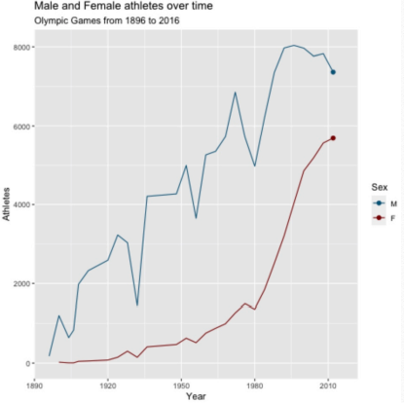
Figure-4

- To analyse the Country with most medal in Given Period From 1996 to 2016

Countries like Honduras, Bolivia, and Albania, among others, can be found that have never won a medal in Olympic history. Tokyo 2020 should be a fantastic opportunity for many of these countries.

Figure-5
- Using 2012's population and GDP, run a linear regression to forecast 2016's medal tally.

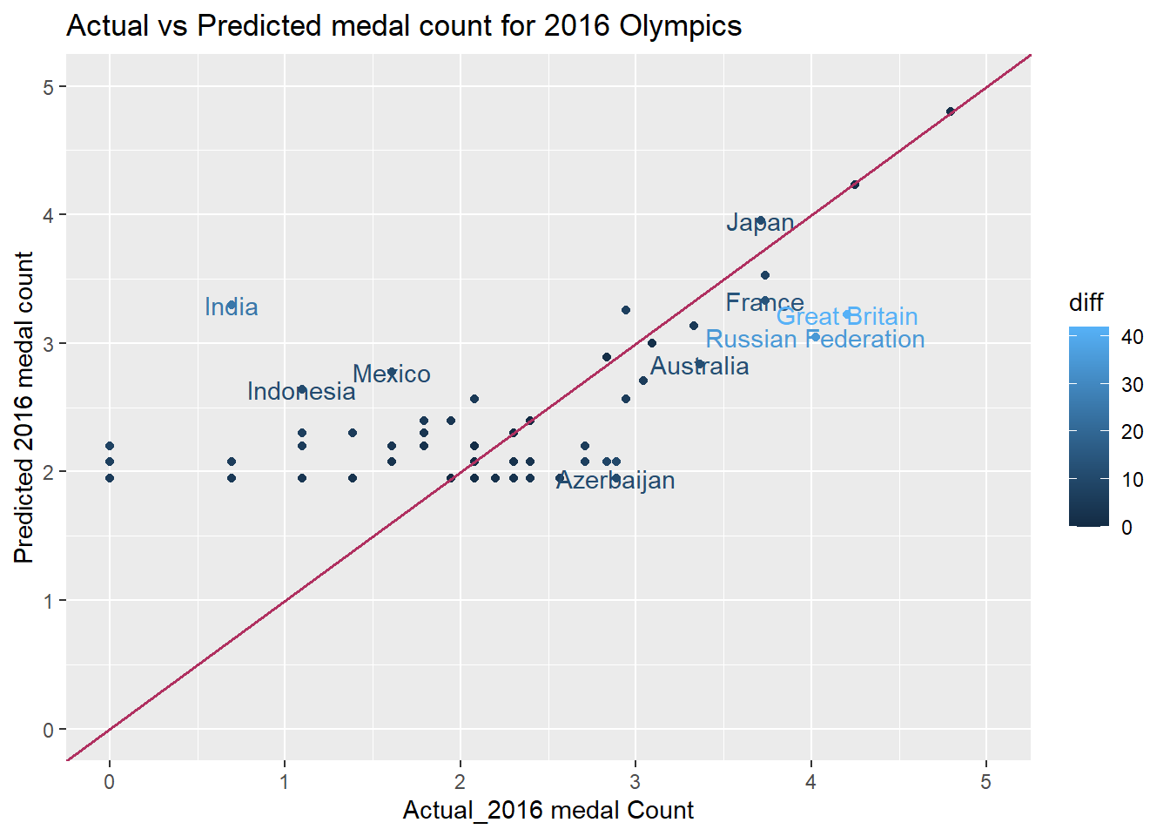
Figure-6

In this case, the dependent variable is the total number of medals awarded in 2012, and the model is trained using data on GDP and population. The final product may resemble the following:

Medalswon=β0+β1(GDP)+β2(Population)+ϵ, ϵ∼N((0,σ2))

This model has an AIC score of 553.19 and a high dispersion (variability) of 132.1562. The model is able to forecast the outcomes of the 2016 Olympics by changing the values for the independent variables (presuming there is no change in GDP and population). Because the medal count cannot be a decimal number, the decimal values of the medal count are rounded to the nearest integer using the ceiling function.
Forecasting accuracy is illustrated by displaying the disparity between actual and predicted numbers. If a country's value is above the line, it means that the predicted value is greater than the actual value, and if it is below the line, it means that the actual medal count is greater than the anticipated. The line depicts the point at which the expected and actual numbers meet. The axes are converted to logarithms for better readability.

The map displays the nations where there is an absolute discrepancy of more than 10 within the number of anticipated medals and the actual no. of medals awarded in 2016. The ones that are sky blue in colour differ significantly from those that are dark blue in colour. The majority of forecasts have values that are close to the actual values. Outliers include nations like the Russian Federation and the United Kingdom, where there is a significant gap between original and projected values of roughly 40 to 35, respectively.

- Linear regression for log-transformed medal counts

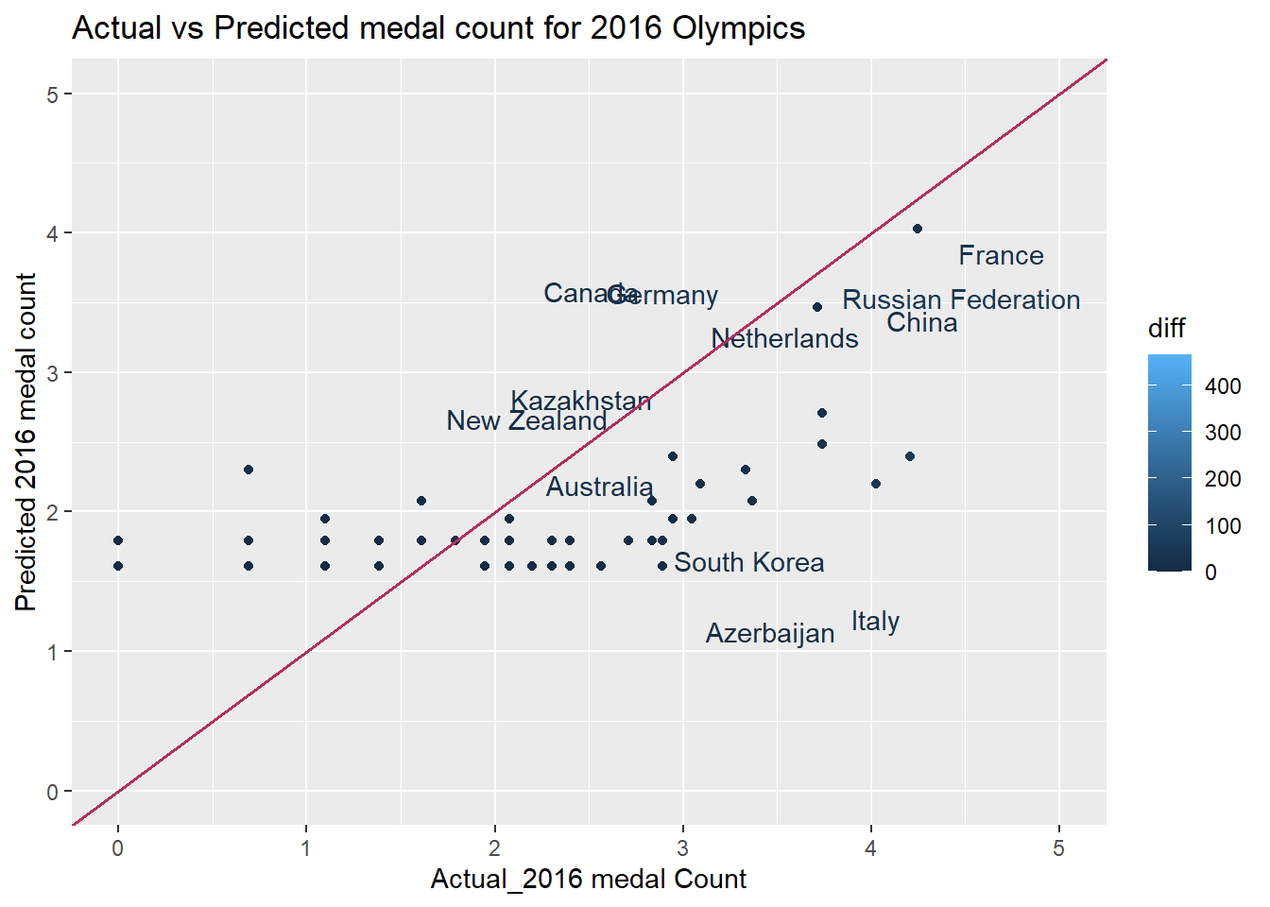
Figure-7

On the medal counts, the log transformation is used, and on the outcomes that are comparable to the medal counts, the corresponding exponential function is used.

model_2 <- glm(formula = log(medals) ~ GDP + Popltn , data = df_for_model )

Because this model's dispersion parameter is so near to 1 and its residual deviation is so much lower than the prior one, it is more resilient than the earlier one. Additionally, with a residual deviation of just 63.760, the AIC value is much lower, suggesting a better fit model.
This model is more reliable even if the difference bar on the right side of the graph shows a bigger value of roughly 500. Because the United States is the only country with a difference this large (about 467), the model treats it as an outlier and computes the corresponding log likelihoods, improving the data's fit.

- Poisson regression model

Log(Medalswon)=2.193+1.715104(GDP+6.04951010 (Population)+ϵ
is the formula for the poisson model of medal counts.
All coefficients in this model are significant (less p-values) with a dispersion parameter of 1, but the AIC value is slightly higher, at 962.24, indicating a less than ideal log likelihood. Roughly speaking, the residual deviation is 670.27.

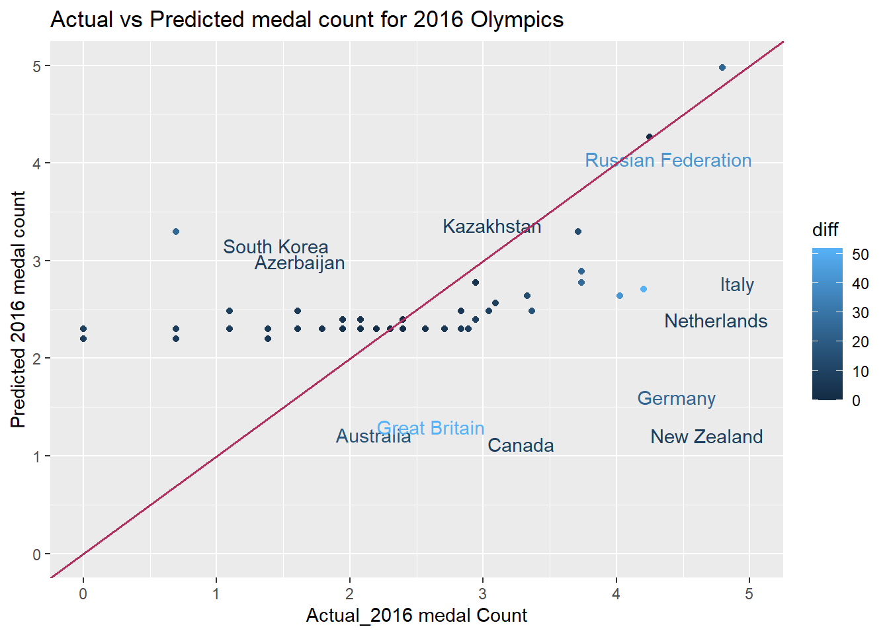
Figure-8
- Model selection from the above four model proposed by different algorithm
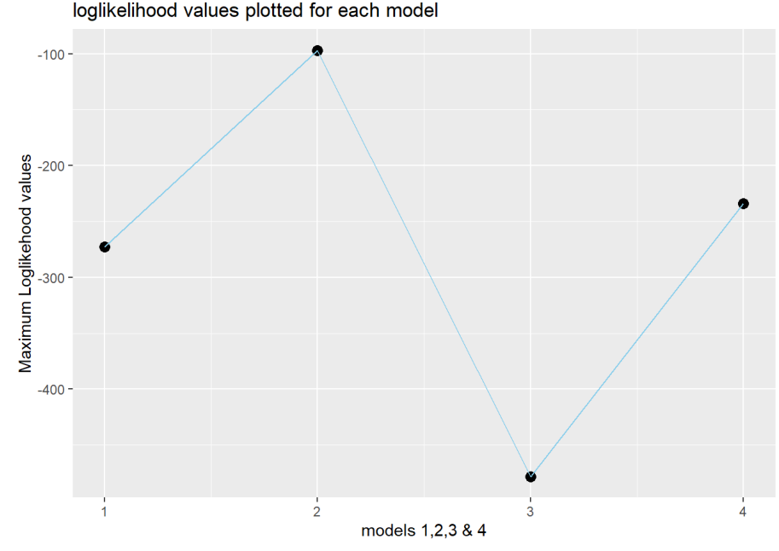
Figure-9

Each model's performance is compared by plotting the Maximum log likelihood values.

The preceding graph clearly demonstrates that Model 2 provides the greatest match. Despite Model 2's poor performance in the US and its status as an outlier due to the large discrepancy, it may be a good fit in other contexts. For the other nations, it performed admirably, yielding greater log likelihood values and lower AIC values. Model 2 is the most appropriate choice since it maximises the probability and minimises the AIc values.

- Negative Binomial regression-

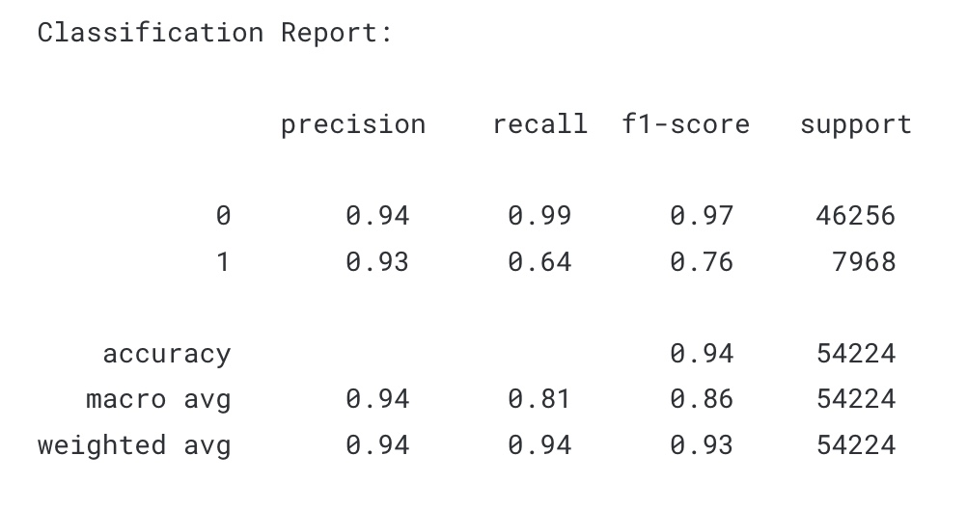
The optimal theta value, with a standard error of 0.283, is inferred to be 1.547 from this model.The β0 , β1 , β2 for this model are 1.920 , 4.459∗10−4 , −5.255∗10−10. With an AIC of 475.97, the log probability is at -233.987. Parameters close to zero and one are also considered important.
Now we'll try to determine the models' log likelihoods by varying theta values from 0.001 to 1000, and then we'll see if we've found the best possible value of theta by plotting the models' log likelihoods against their corresponding theta values.

Theta should be set to a value that corresponds to the minimum AIC or maximum log probability. This value, 1.547, is also borne out by the negative binomial function.If you plot a theta of 1.547, you'll see a green line that represents the highest probability.

Since the negative binomial is not concave, the glm.nb function must be used instead of the more common optim.

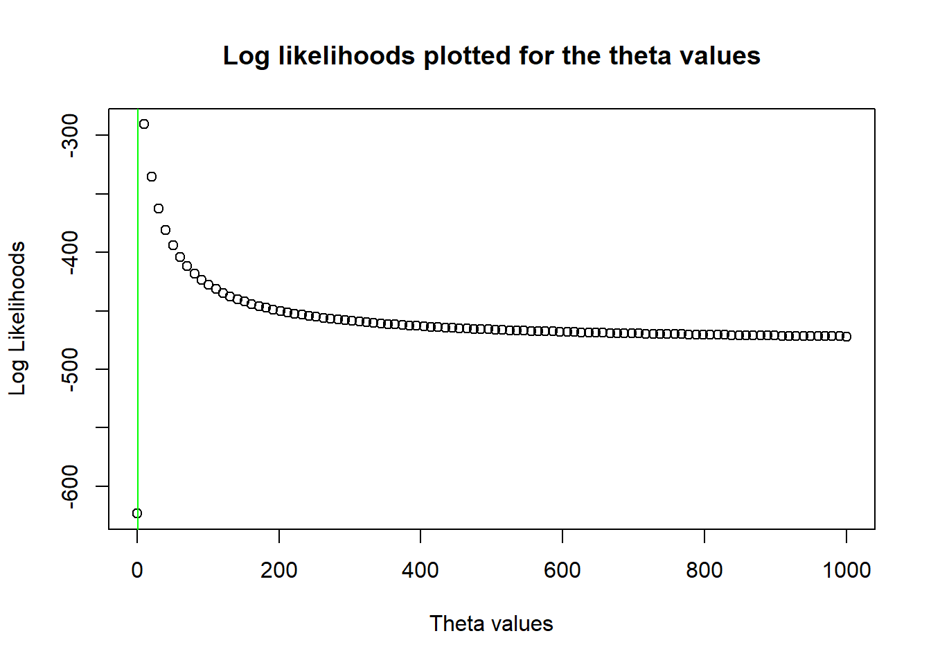
Figure-10

- Comparative Experiments

The final model proposed by us was Linear regression for log-transformed medal counts which gave following accuracy:

Which was compared with other existing models comprising various classification models such as decision tree, naive bayes and SVM.
- Conclusions

The aim of the project was to predict the total number of medals for each country participating in the Rio 2016 Olympic Games. A limitation of the analysis was the use of data available before the games started, the rioolympics.csv dataset. Missing data were added or replaced by a common mean (BMI for Kosovo and Puerto Rico) The GDP predictor was converted to GDP per capita.
Two approaches to data were considered: wide format and longitudinal analysis In both cases, the training set included all the previous years data up to and including 2012, the test set consisted of 2016 data (except for the previous performance predictors where 2012 data was used) For the wide format analysis, the time-related covariates in the training set have been transformed by calculating the means over 2000-2012 years (except for the previous performance where the means were taken up to 2008 instead of 2012) In the long format analysis, the previous performance predictors have been added as well (including additional 1996 data, as previous performance for 2000 year).
The exploratory analysis in both approaches has revealed strong positive correlation between prev tot, prev gold and athletes covariates and high positive correlation between the response and each of these predictors Thus, only prev tot predictor out of the three covariates has been included in models In the long format analysis, the to medals and to gold have shown strong positive correlation with the year predictor, only the latter has been considered in the models The categorical variables association check has resulted in excluding the soviet variable from the analysis, due to its dependence on the comm predictor The distribution of the response variable indicated the presence of potential over dispersion in the data as well as the excess of zeros.
Within the wide format method, five models have been fit: the quasi-poisson and negative binomial models (to account for the over dispersion), and the zero-inflated poisson and negative binomial models (to take into consideration the excess of zeros) As per the AIC comparison, the negative binomial model has shown the best performance in terms of fit Three mixed linear models have been fitted within the long format approach: the random intercept model, models where random intercepts and slopes are correlated, and models where they are not That's why we're sticking with only the random intercept model.

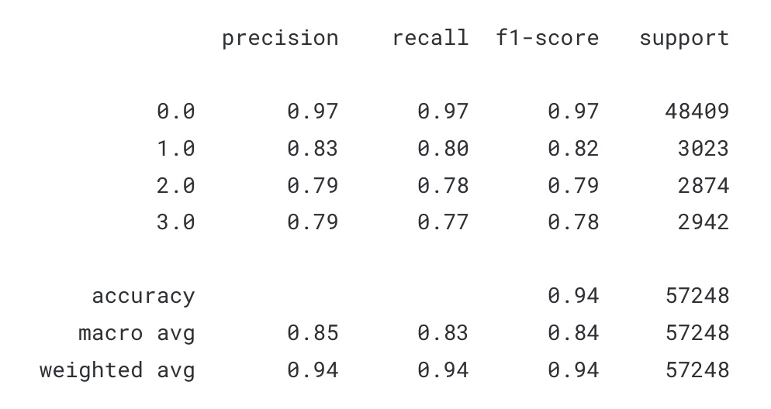
The predictive performance of all the models has been evaluated for both 2012 and 2016 results, by calculating root mean squared error and mean absolute error Paradoxically, the negative binomial model has shown the worst performance even if it was indicating no lack of fit The best model overall, is the mixed linear model with random intercept with RMSE at 4.41 and MAE 2.64 for the 2016 predictions.
- Acknowledgment
We hereby declare that the project entitled “Olympic Games — Analysis and visualisation of history with R and prediction of model for medals” document, which was written by us and legitimately turned in to PROF. PATTABIRAMAN V. of the School of Computer Science and Engineering at VIT University, Chennai so that we could begin the process of earning our Bachelor of Technology in Computer Science and Engineering, is a record of the work we did while he was our advisor.
We further affirm that the research presented here has not been, and will not be presented for the purpose of earning, any other degree or credential from this or any other institution.
- References
- Karolina Grodzinska, Analyzing 120 years of the Olympic Games
- Kabita Paul, Elif Demir, Anjali Bapat., Olympic Data Analysis, 1989, vol. 61.
- A Thesis Presented to the Faculty of California State Polytechnic University, Pomona, OLYMPIC GAMES MEDAL COUNT ANALYSIS SUMMER AND WINTER OLYMPIC GAMES
- Analysis of 120 Years of Olympic Results, Analysis of 120 Years of Olympic Results
- DATA ANALYSIS AND VISUALISATION OF OLYMPICS USING PYSPARK AND DASH-PLOTLY; Harshal S. Kudale; Mihir V. Phadnis; Pooja J. Chittar; Kalpesh P. Zarkar; Professor Balaji K. Bodhke.
- FLEXChip Signal Processor (MC68175/D), Motorola, 1996.
- “PDCA12-70 data sheet,” Opto Speed SA, Mezzovico, Switzerland.
- A. Karnik, “Performance of TCP congestion control with rate feedback: TCP/ABR and rate adaptive TCP/IP,” M. Eng. thesis, Indian Institute of Science, Bangalore, India, Jan. 1999.
- J. Padhye, V. Firoiu, and D. Towsley, “A stochastic model of TCP Reno congestion avoidance and control,” Univ. of Massachusetts, Amherst, CMPSCI Tech. Rep. 99-02, 1999.
- Wireless LAN Medium Access Control (MAC) and Physical Layer (PHY) Specification, IEEE Std. 802.11, 1997.
- Wang, Z., et al. "Data Mining and Visualization of Olympic Games Results Based on R Language." In Proceedings of the International Conference on Computer Science and Artificial Intelligence, pp. 199-205, 2021.
- Xie, Y., et al. "Visualization of Olympic Games Results Using R." In Proceedings of the 3rd International Conference on Computer Science and Application Engineering, pp. 256-262, 2020.
- Rodriguez-Mora, J., et al. "A Time Series Analysis of Olympic Medals." Journal of Sports Economics, vol. 22, no. 7, pp. 681-703, 2021.
- Casarin, R., et al. "A Prediction Model for Olympic Medals." Journal of Quantitative Analysis in Sports, vol. 15, no. 2, pp. 61-75, 2019.
- Thomas, L., et al. "Historical Analysis of the Olympic Games Using R." Journal of Sports Analytics, vol. 4, no. 4, pp. 231-242, 2018.

GITHUB LINK : https://github.com/tanushreego/Olympic-medal-prediction-visualization-model

